Graphs in data strcutrue
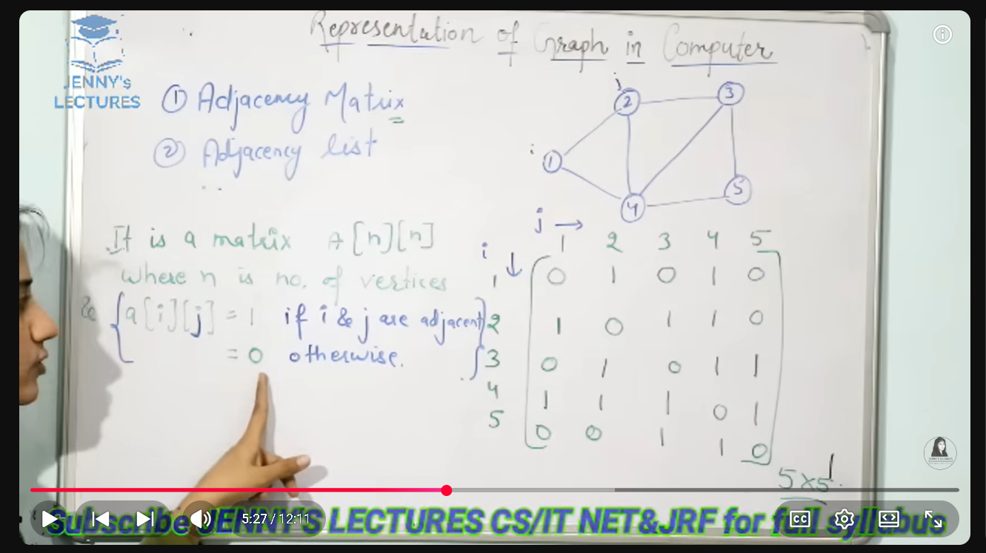
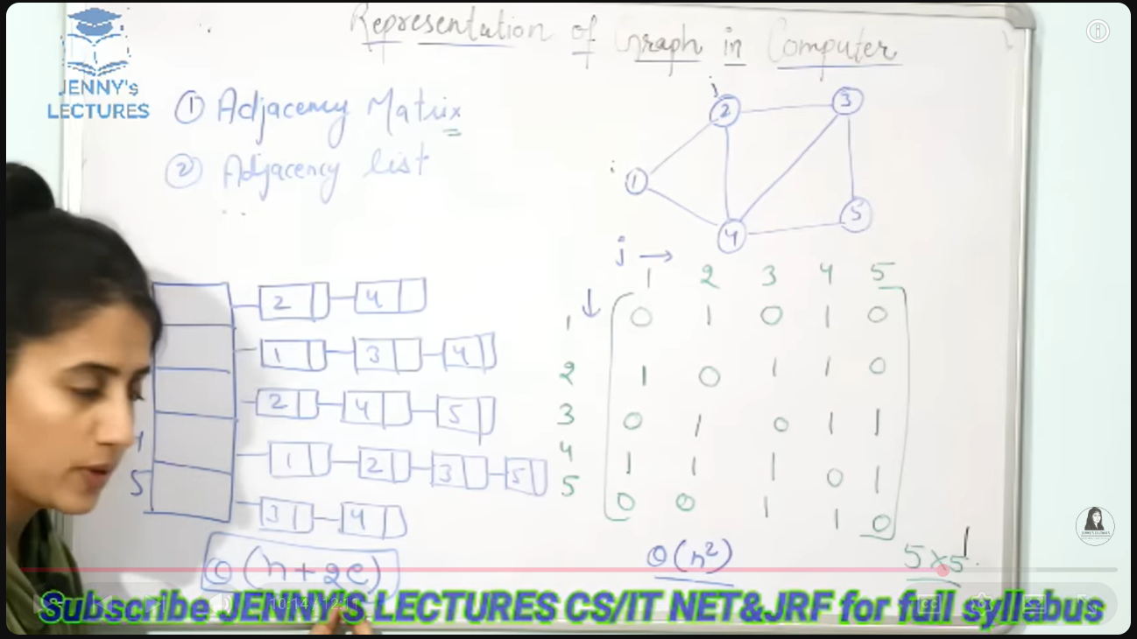
When the graph is dense its better to use adjaceny matrix and when graph I sparse its better to use adjacency list
Dense graph means each node is connected with each other like that
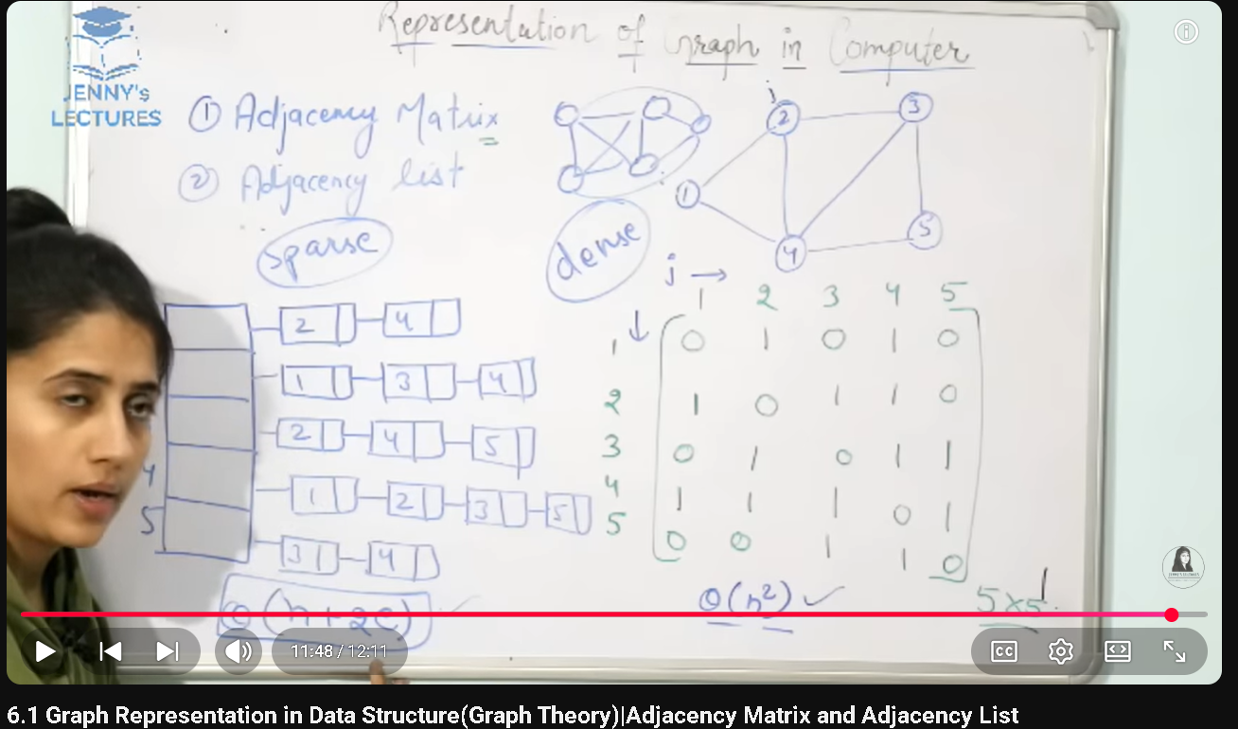
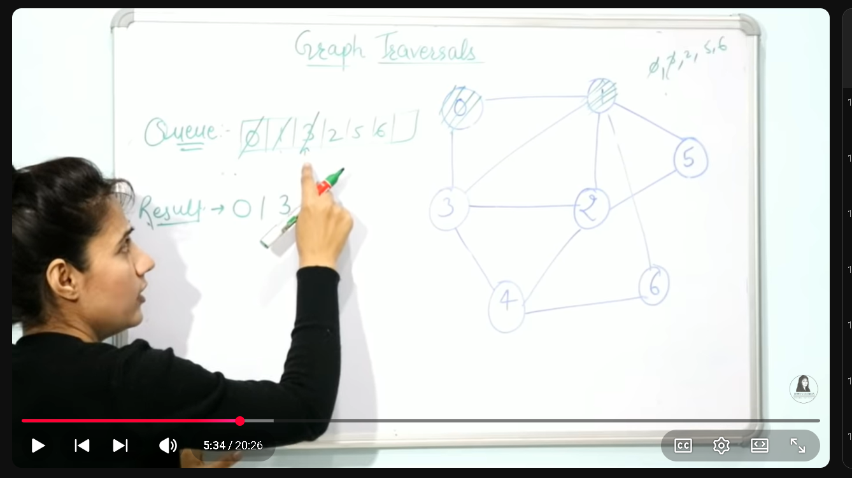
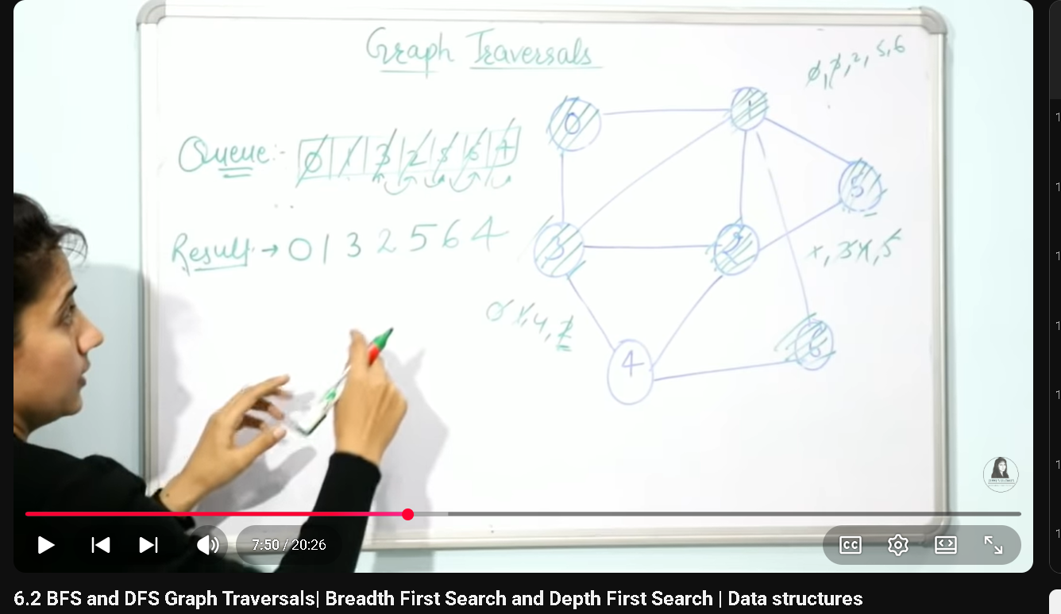
Bfs implementation hai yai is ami queue data structure use hota hai dfs mai stack data structure use hota hai
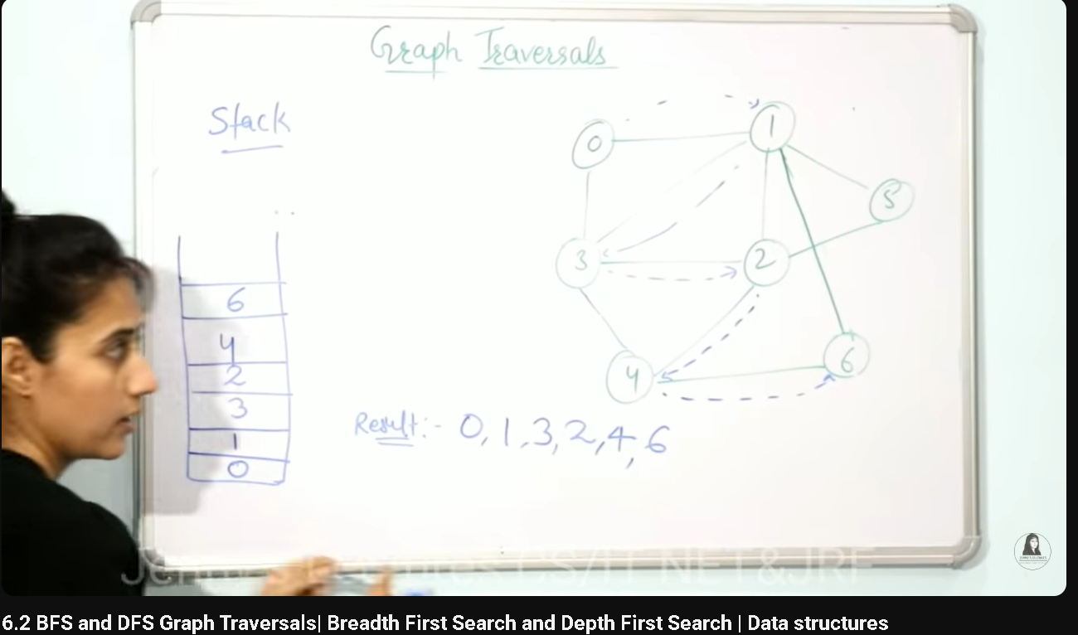
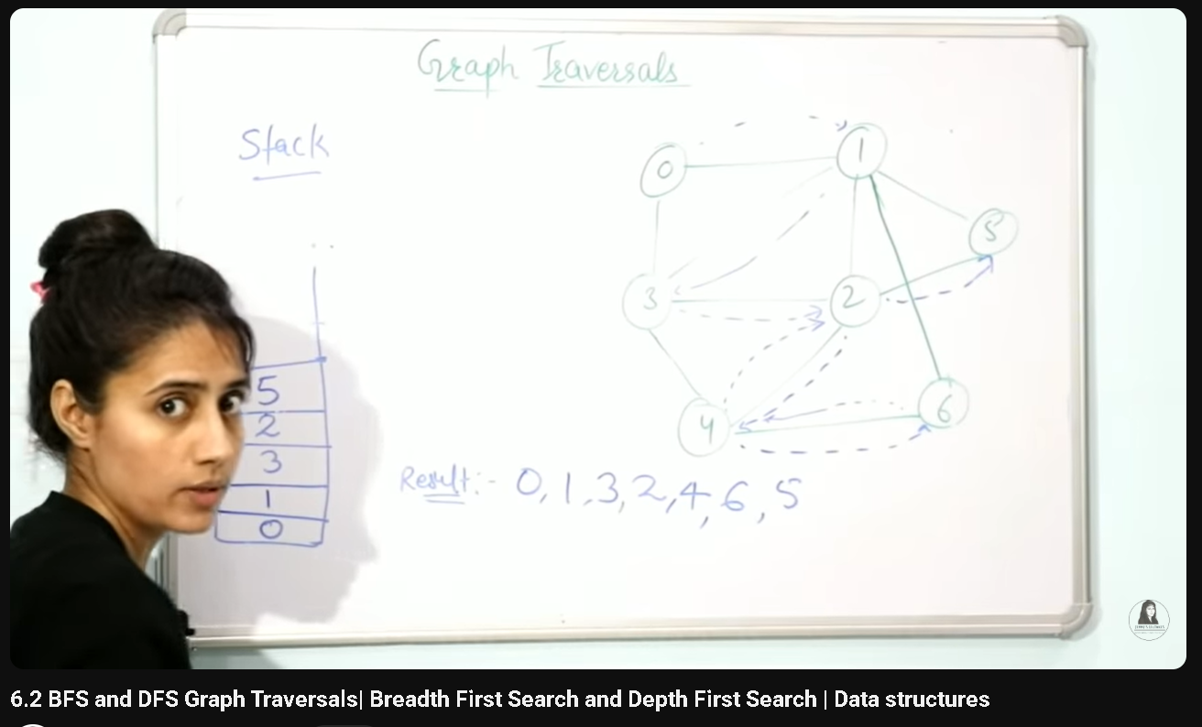
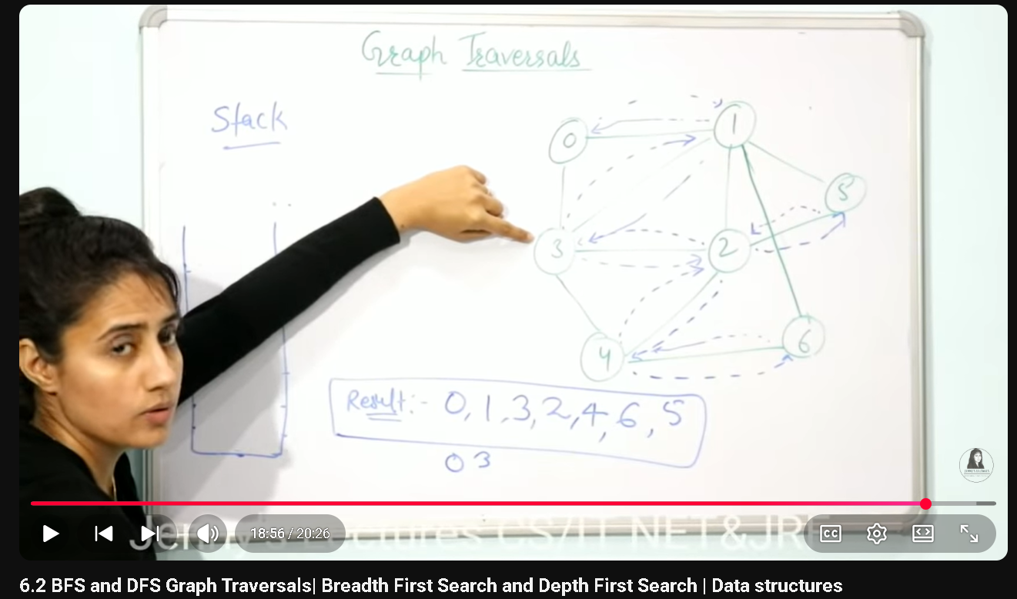
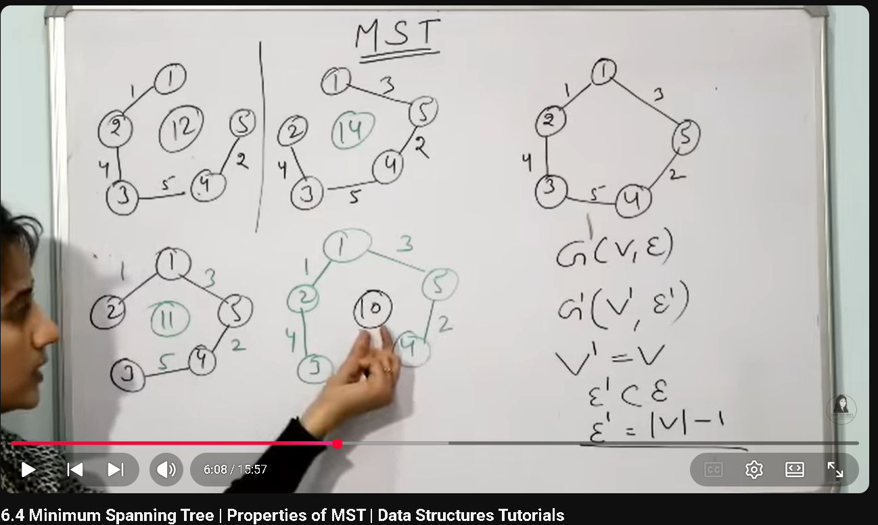
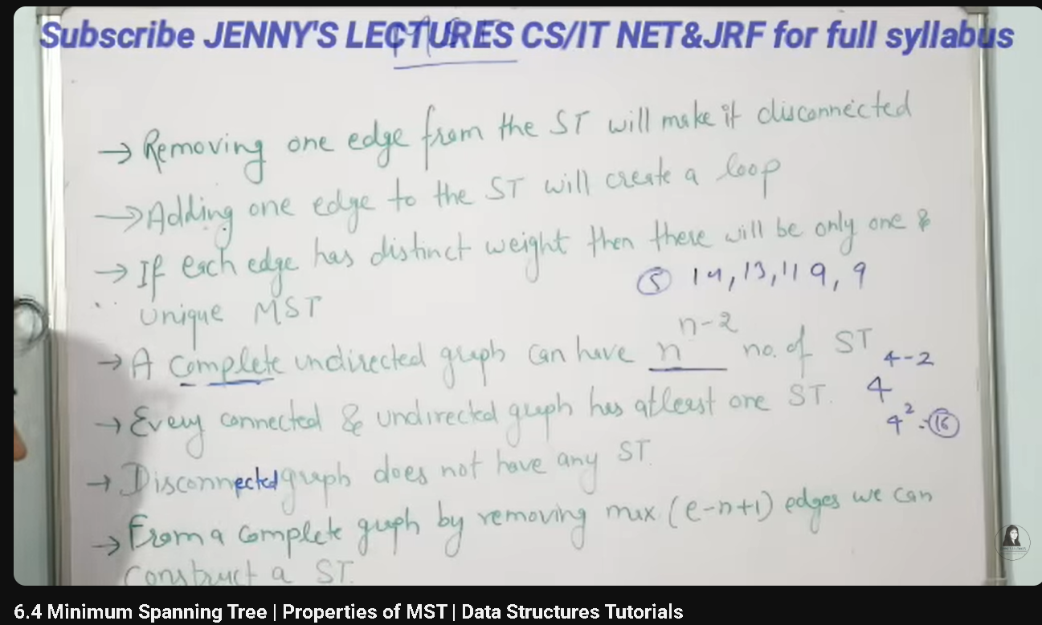
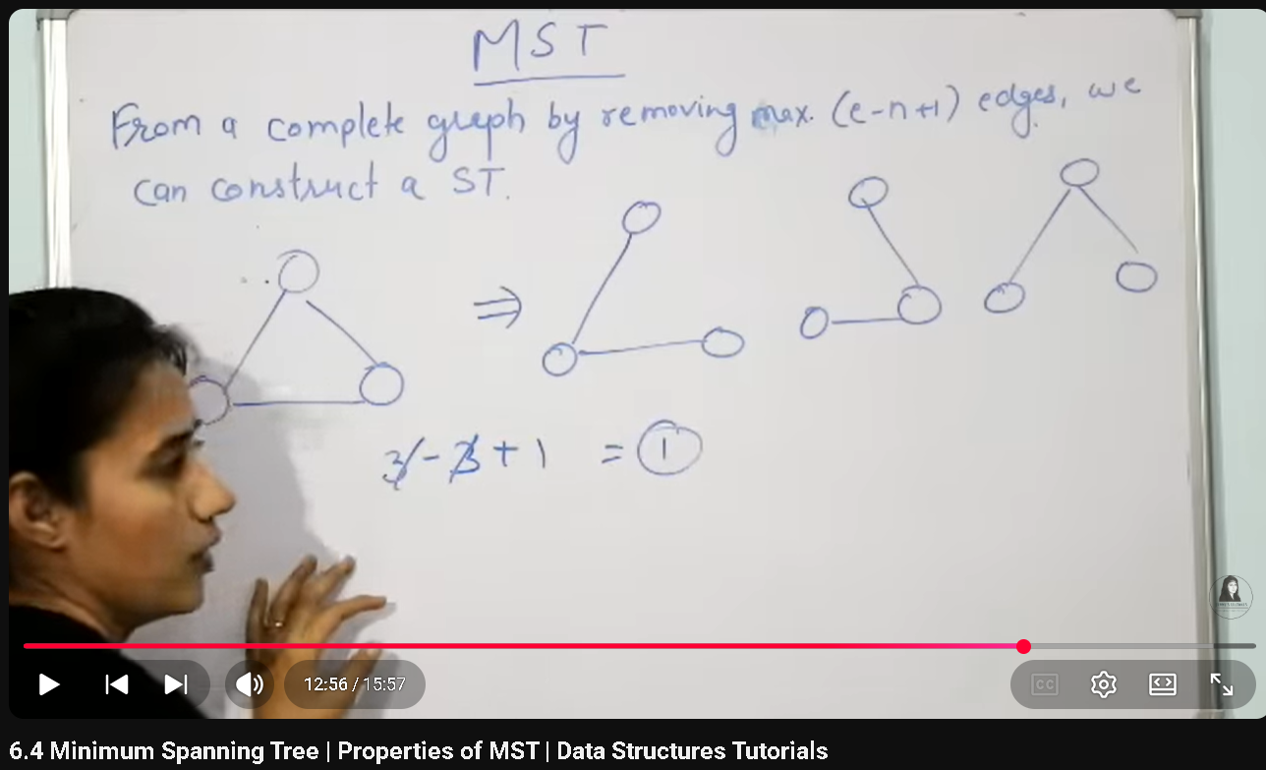
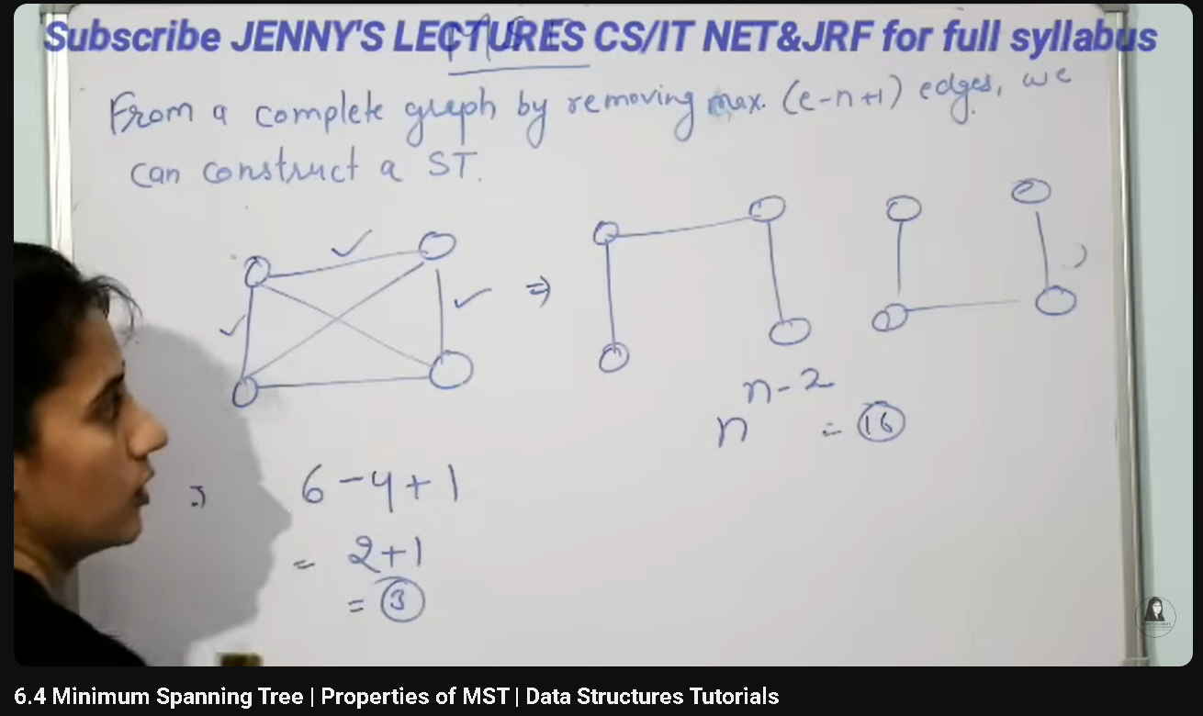
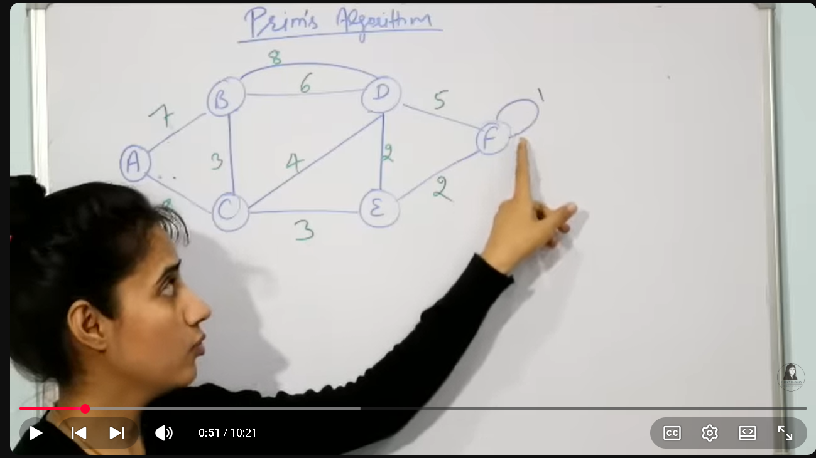
First step: remov all loops and para leel edgs
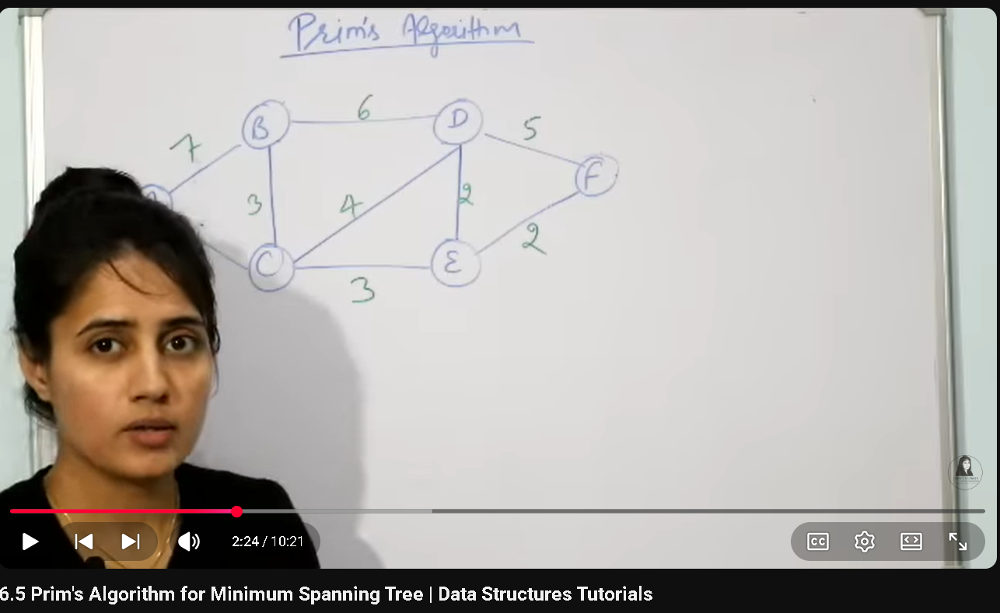
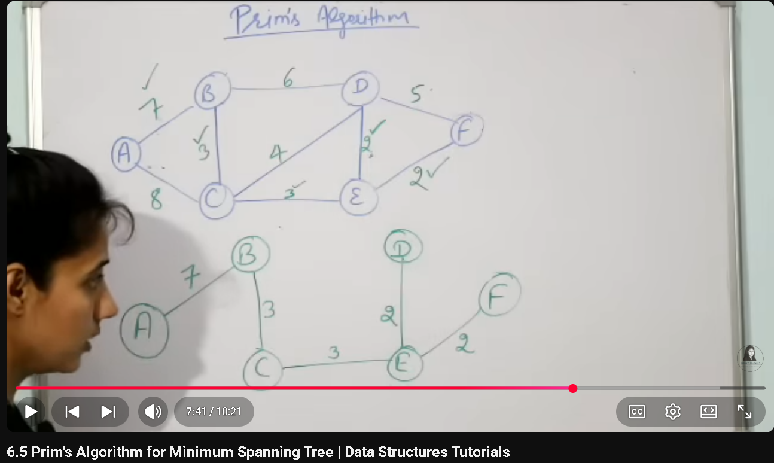
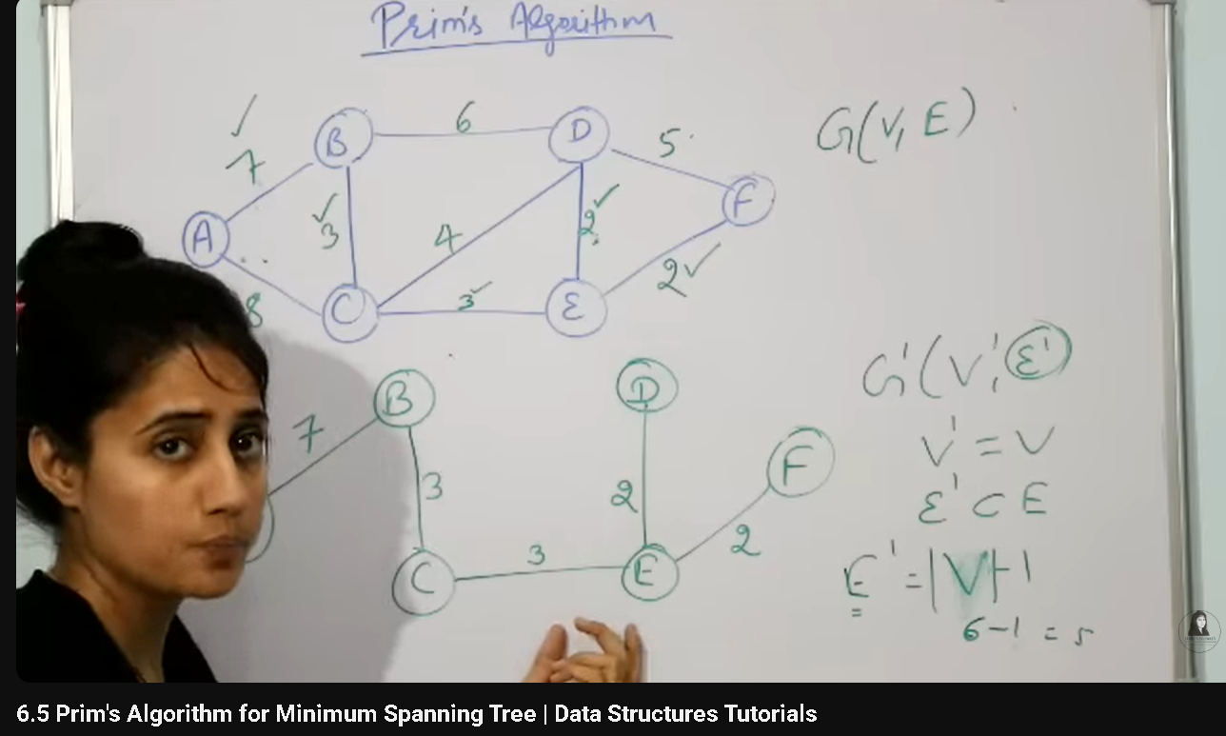
Kruskal
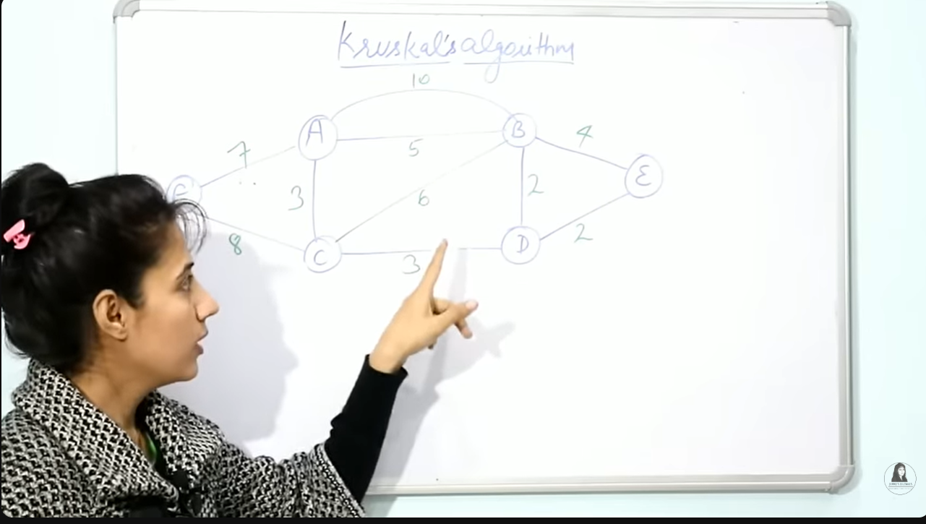
First step: reome cycle and parallel edges
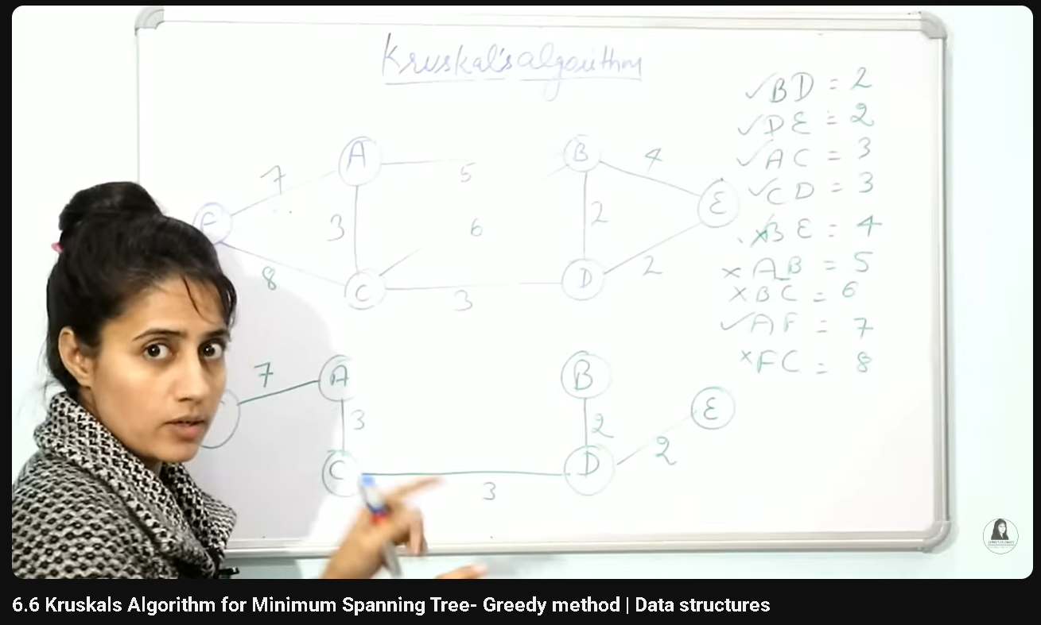
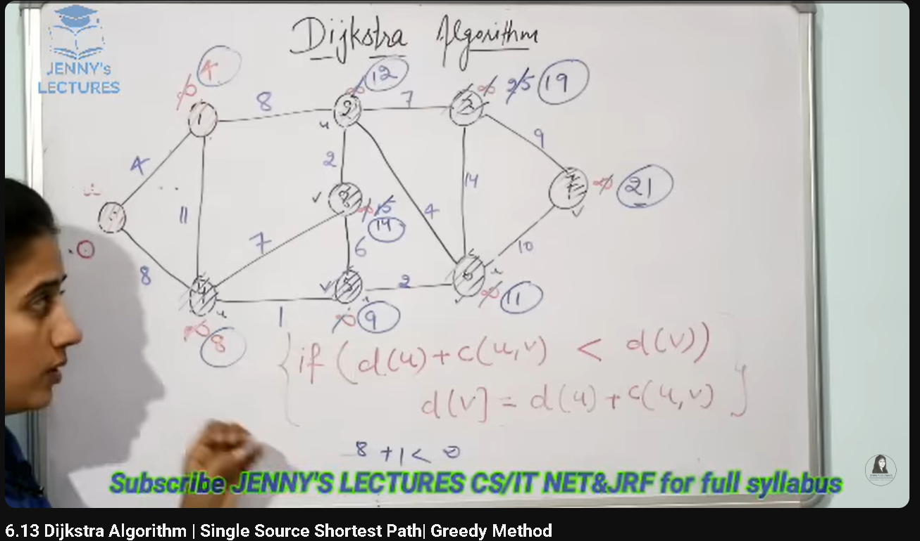
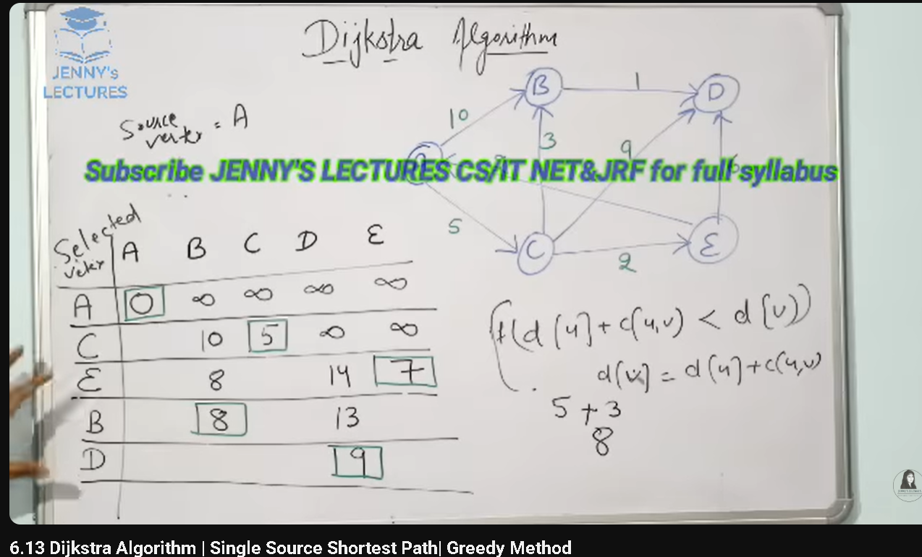
Bellman ford is different from dijistr algorithm because in negative weognts dijistra algorithm does not gurantee the correct anser not work on negative weights bul belma ford worked
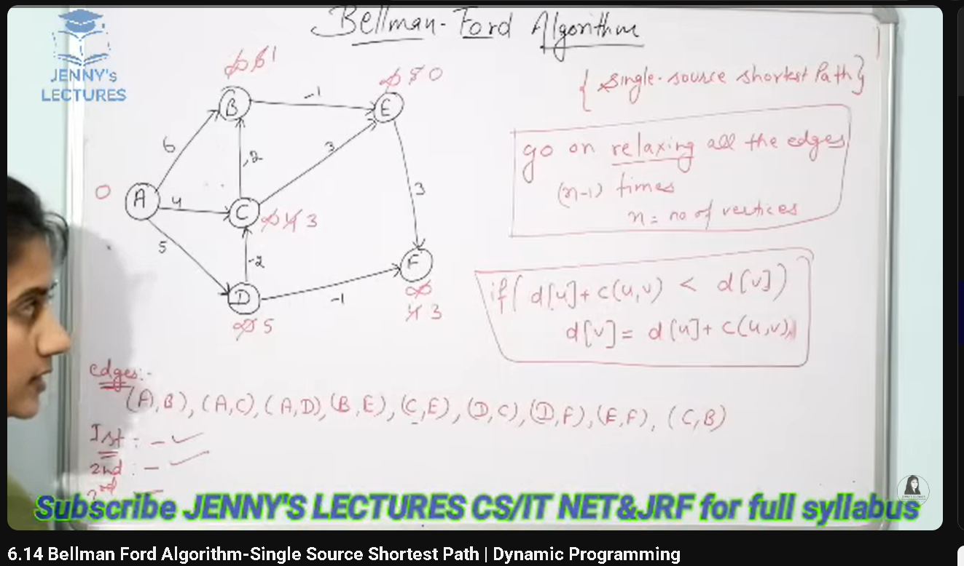
If the graph contains negative sum cycle it will not work correctly but its work okay if it contains negative edge
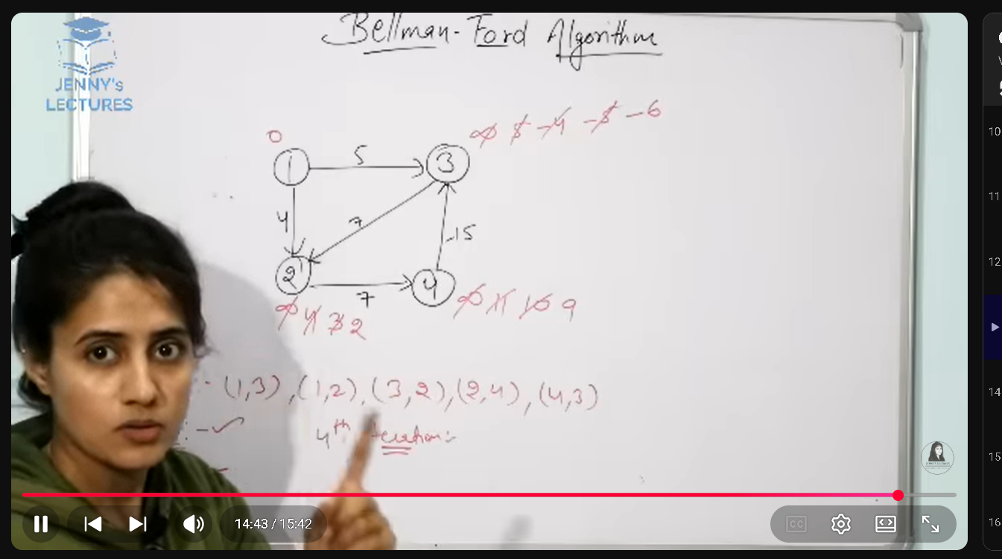
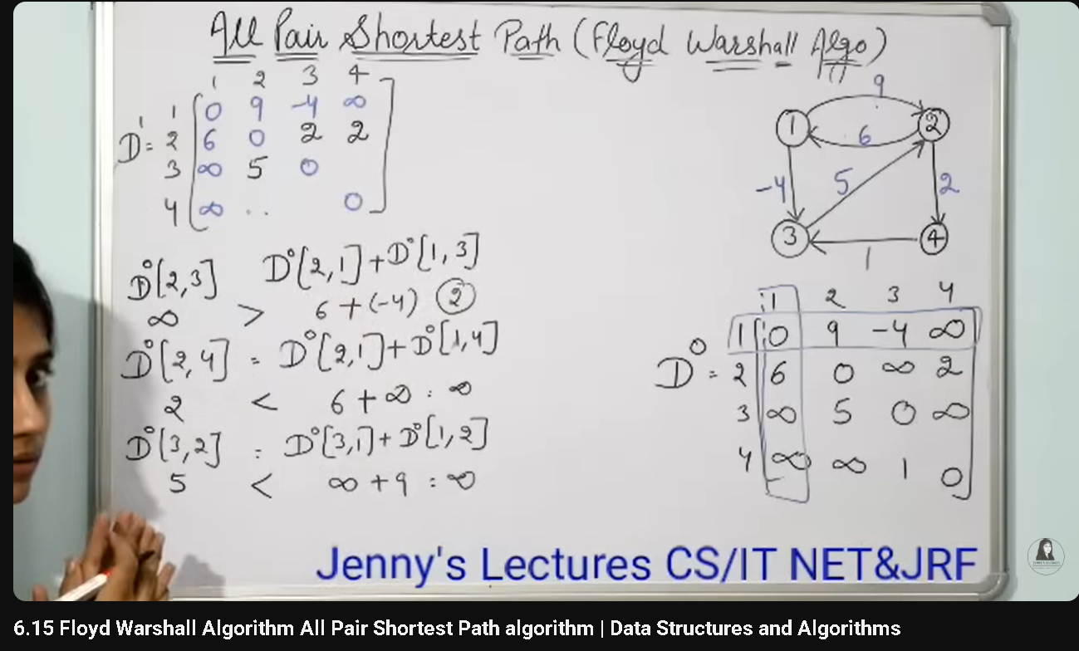
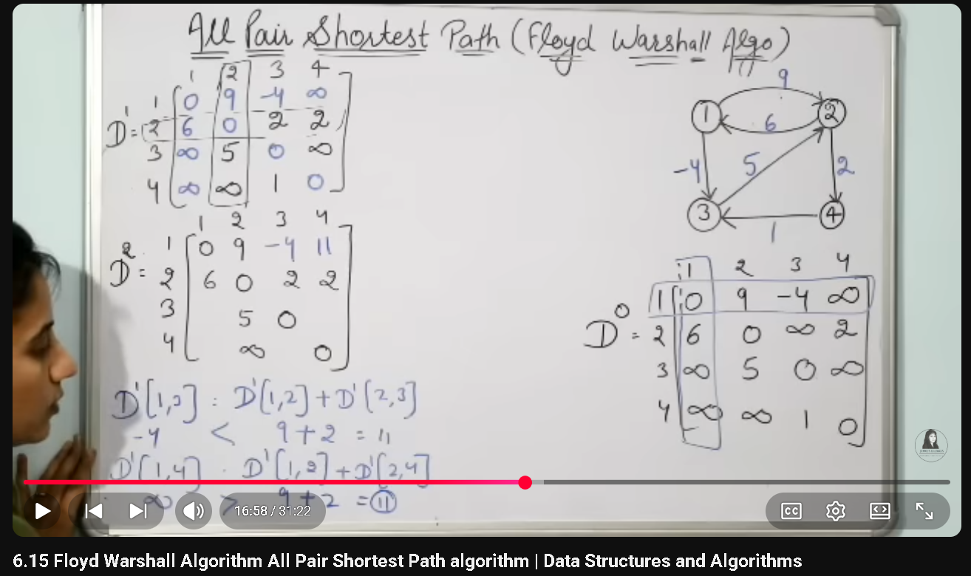
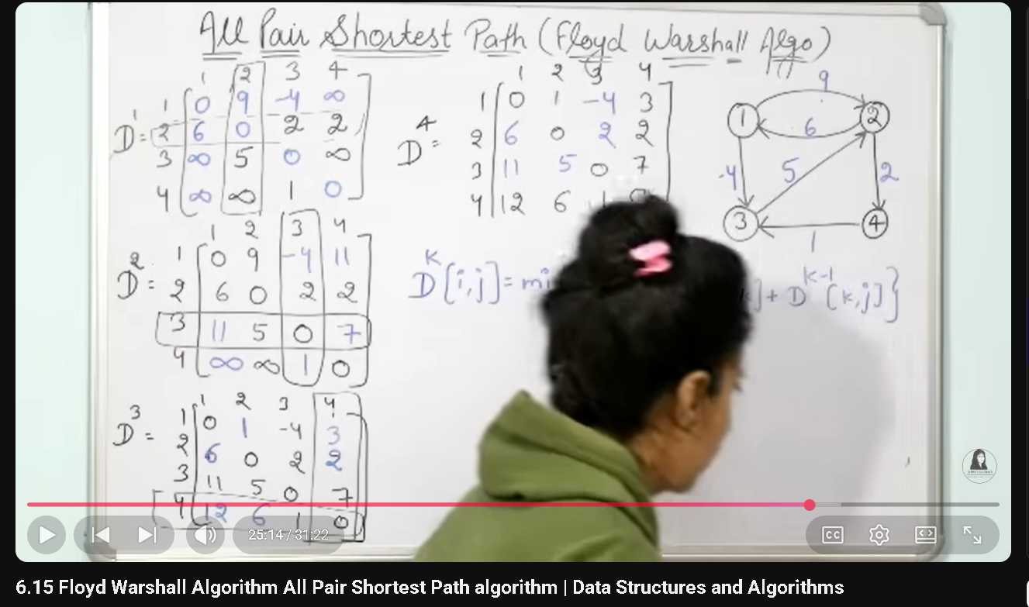
Floyd warshell is okay to use when the graph is dense it work on positive and negative edges if the graoh is sparse and having only positive weights then dijistra is better
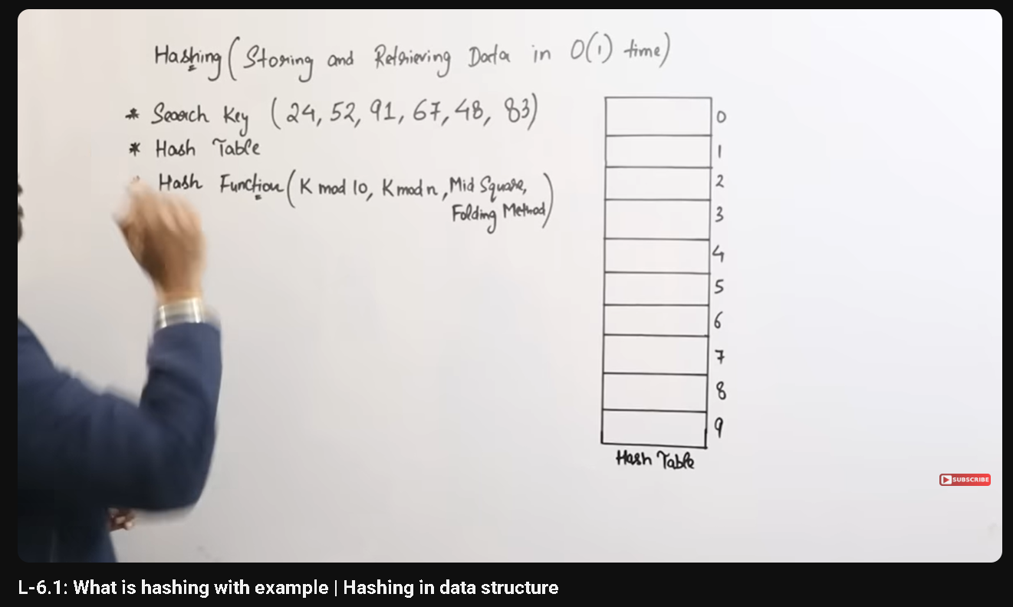
Hashing
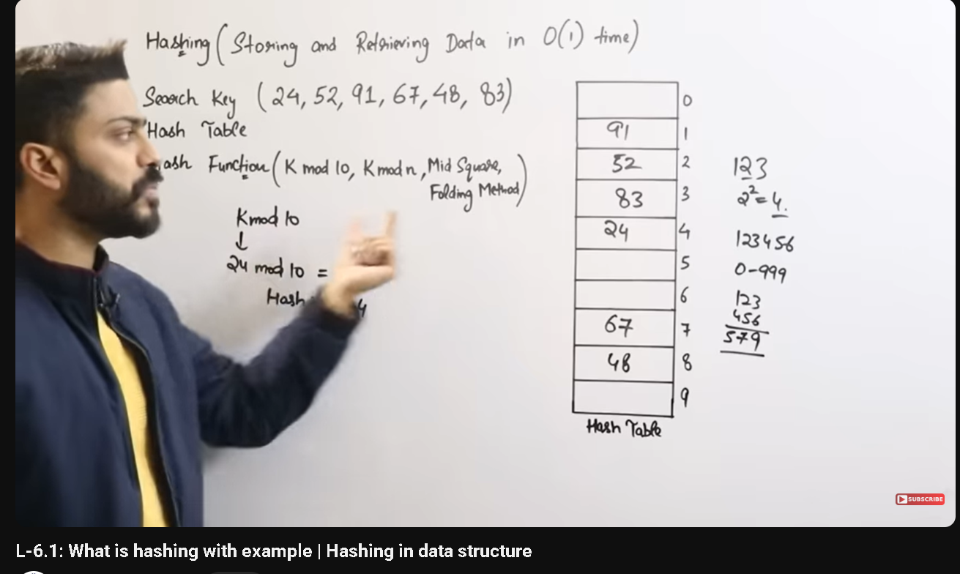
0(1) time mai insertion or deletion ho gati hai

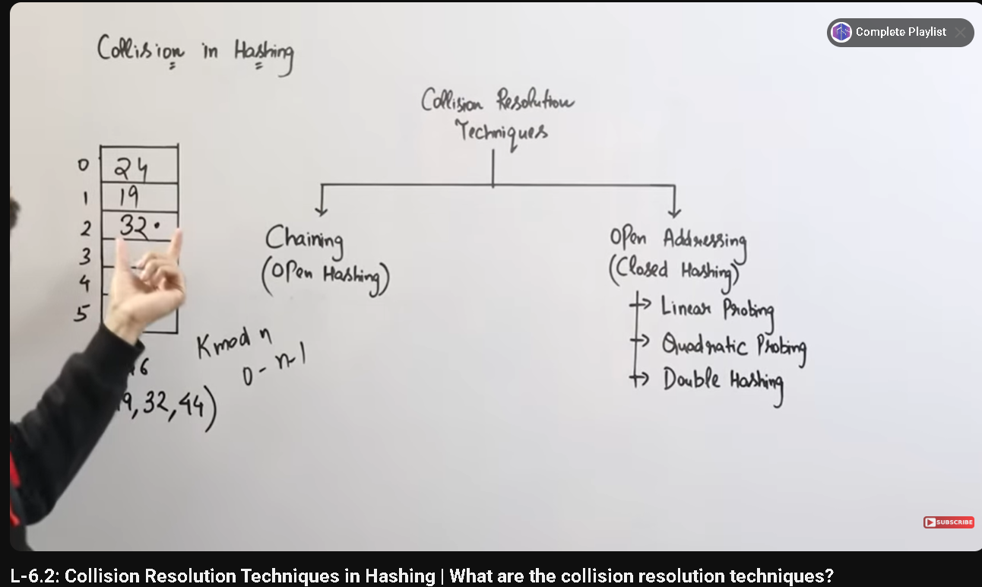
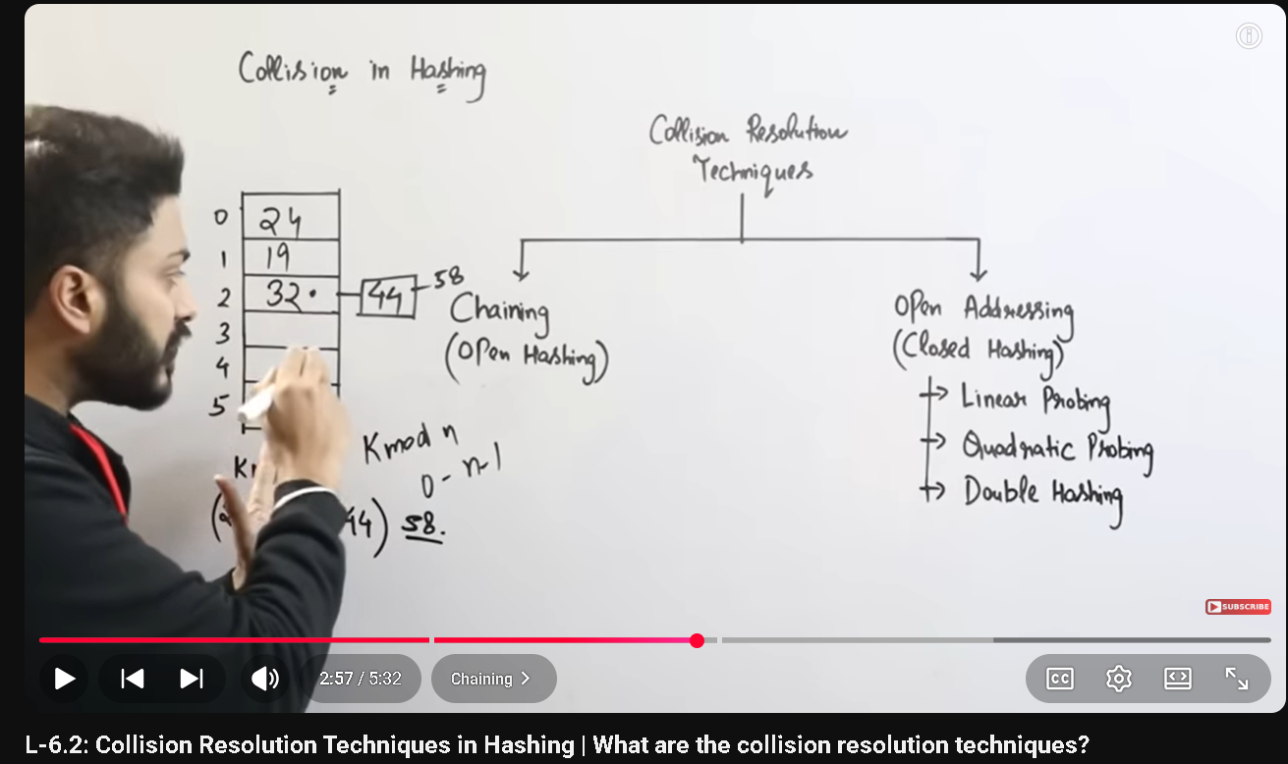
Open hashing mai ham extra soace use krtay hai extra linked list bnatay ahi existing space use nhi krtay
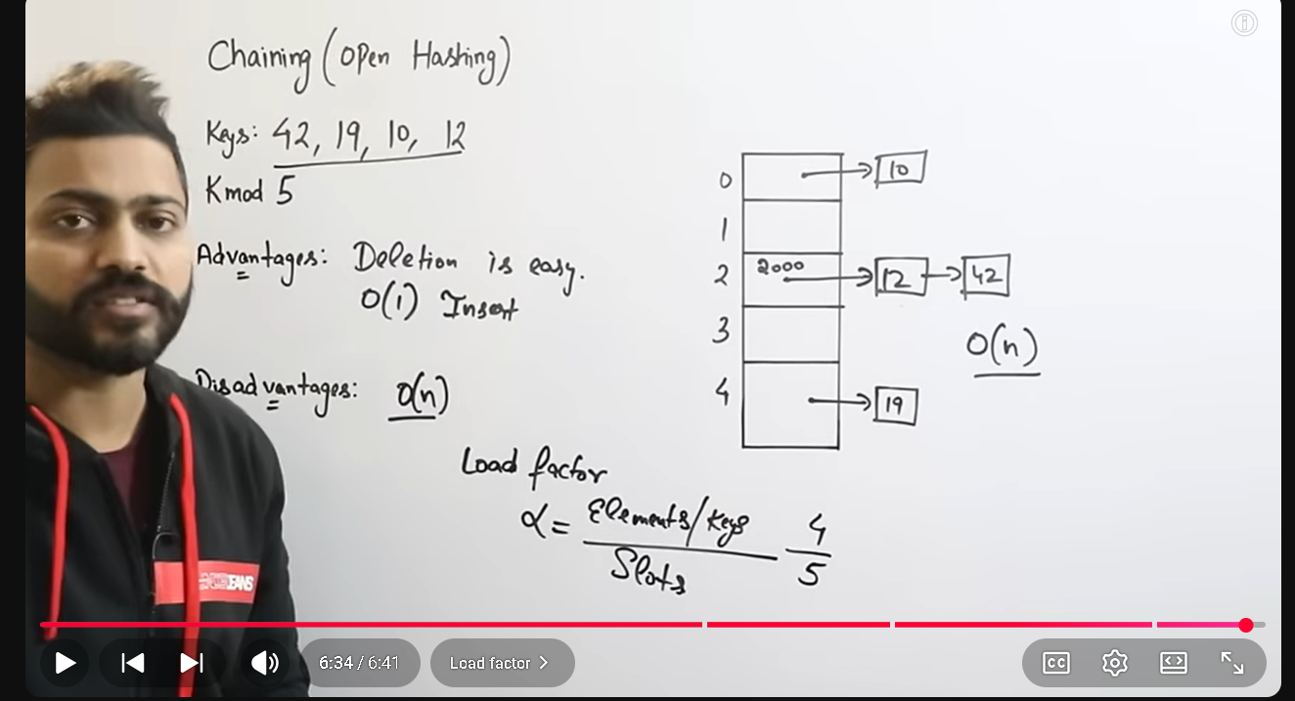
disadvantage open hashing kai yai hai kai searching mai time 0(n) tak ag sakta hi
Linear probing
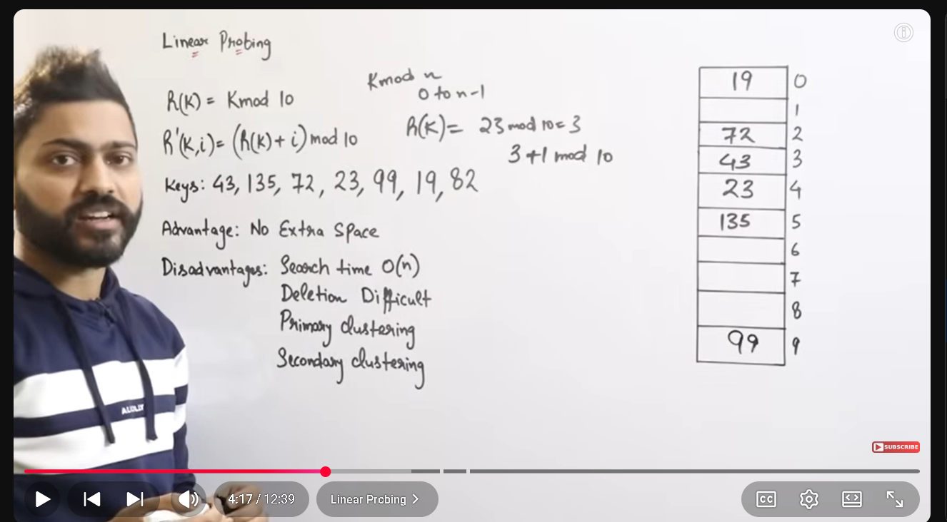
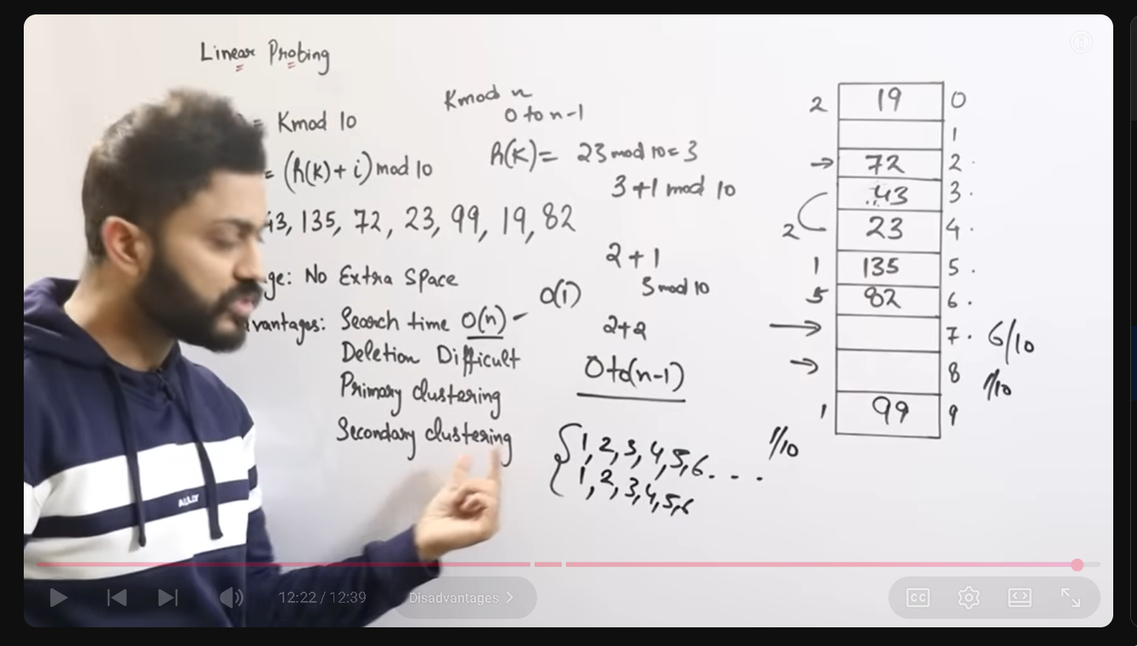
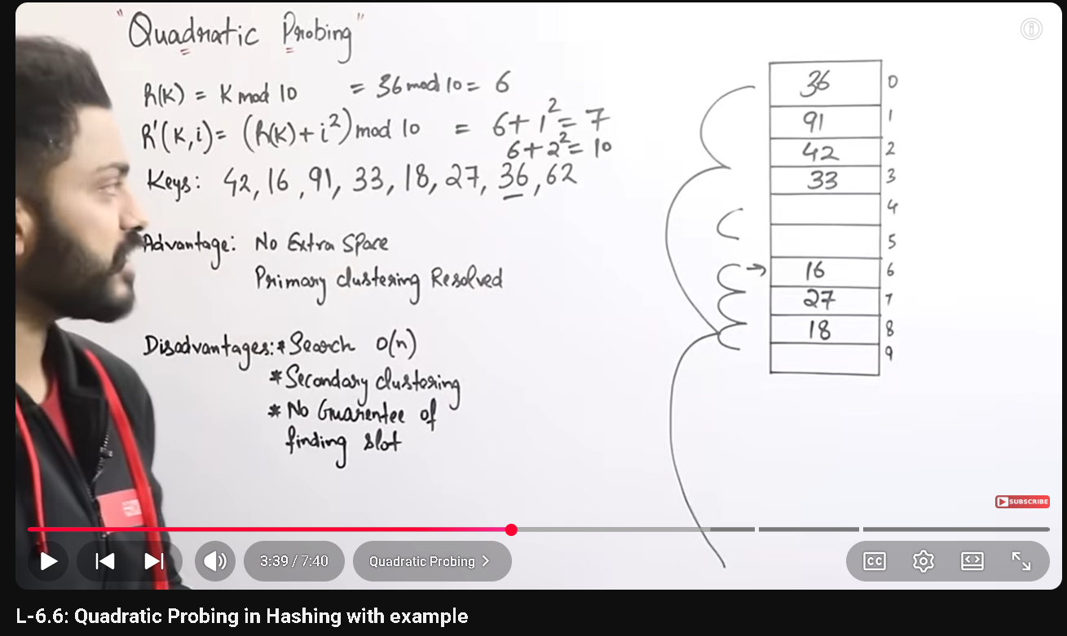
Gab collision aye gi tab quadratic formula us krna hai warna linear wala hi use krna hai
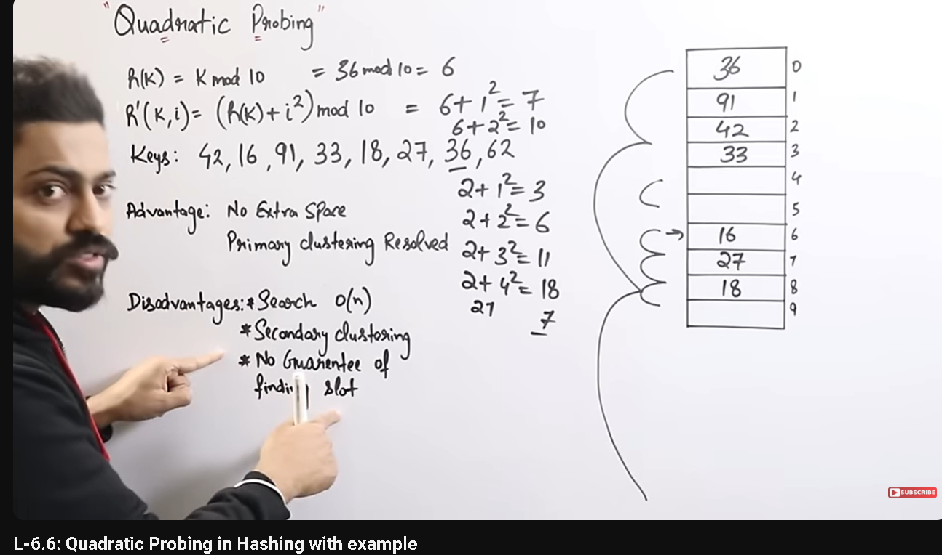
Gab half dull ho gaye to quadratic probing mai values dalnay kai liye probing kai formual sai index hi milta loop mai phas gatay hai although space hoti hai lekin formula sai wo values nhi milti go khali ho or loop mai phas gatay hai
Double hashing
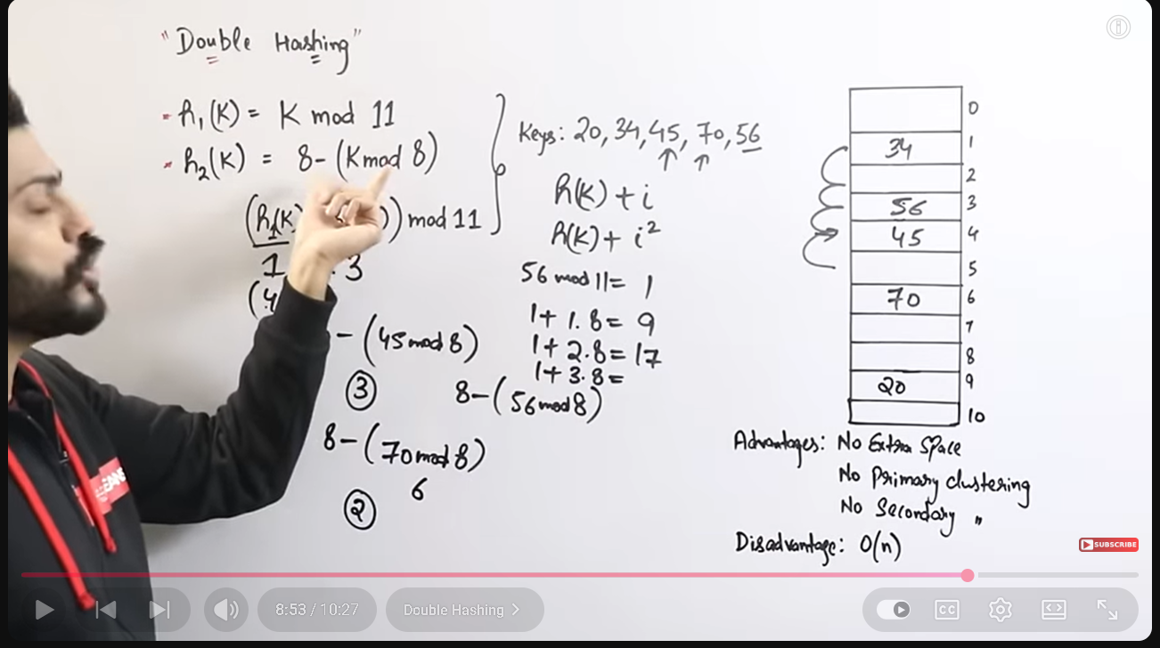
Double hashiong amek sure krta hai saray index fill ho sab ko values milay or is mai primary clisutering or secondary clustering bhi nhi banti

